Training document for the company-wide
automation solution
Totally Integrated Automation (T I A)

MODULE A1
Totally Integrated Automation (T I A)

This document was provided by Siemens A&D SCE (automation and drive technology, Siemens A&D Cooperates with Education) for training purposes. Siemens does not make any type of guarantee regarding its contents.

The passing on or duplication of this document, including the use and report of its contents, is only permitted within public and training facilities.

Exceptions require written permission by Siemens A&D SCE (Mr. Knust: E-Mail: michael.knust@hvr.siemens.de). Offences are subject to possible payment for damages caused. All rights are reserved for translation and any case of patenting or GM entry.

We thank the company Michael Dziallas Engineering and the instructors of vocational schools as well as further persons for the support with the production of the document

PAGE:

1. Forward 4

2. What is T I A 5

3. Presentation of the Various Systems 7

3.1 The SIMATIC PLC- Controllers 7

3.1.1 SIMATIC S7-200 7
3.1.2 SIMATIC S7-300 8
3.1.3 SIMATIC S7-400 9

3.2 Industrial Communication 10

3.2.1 Industrial Ethernet 11
3.2.2 PROFIBUS 12
3.2.3 AS- Interface 13

3.3 Human Machine Interface (HMI) 14

3.4 SIMATIC Industry Software 15

3.4.1 STEP 7 15
3.4.2 Sequencer programming S7-GRAPH 16
3.4.3 State control S7-HiGRAPH 17
3.4.4 High level language S7-SCL 18
3.4.5 Soft- PLC SIMATIC WinAC Basis 19
3.4.6 SIMATIC ProTool/Pro 21
3.4.7 HMI SIMATIC WinCC 22
3.4.8 Process control system PCS 7 23

3.5 Drive Technology 24

3.6 Operation- and Installation Technology 26

The following symbol stands for the specified module:


Information

1. Forward

The module A1 is assigned content wise to the Basics of STEP 7- Programming and represents a quick start in the STEP-7 Programming.

Basics of

STEP 7- Programming
2 - 3 days A modules

Additional functions of
STEP 7- Programming
2- 3 days B modules

Industrial field bus
systems
2- 3 days D modules
Process
visualization
2- 3 days F modules
Sequencer
programming
2- 3 days C modules C

IT- Communication
with SIMATIC S7
1- 2 days E modules

Learning goal:

The reader is introduced to the philosophy of Totally Integrated Automation (T I A).
Therefore the reader should receive an overview of the several components for the realization of this fully integrated automation. These components are shown in applications in the following modules.

Requirements:

No practical applications are generated in this module, so there are no special requirements for it’s execution.

Required Hardware and Software

Special hardware and software does not come into operation here. This module is clearly theoretic.

2. What is “T I A“
Totally Integrated Automation stands for a new concept to realize industrial automation tasks. Existing automation solutions are together composed from a mix of different system technology and manufacturers.
Programmable logic controllers are employed in the field level whereas the cell level uses a mixture of PC and PLCs and the process control level only uses PCs.
So far it is customary that each of these systems uses a whole different type of software and user interface. Additional differences result as soon as different manufacturers provide the components or include enhancements.
By the variety of these different solutions, frequent communication problems occur. Data must be read or written multiple times so that no consistent concept for the preparation of large data quantities exists.
The fundamental idea is a consistent technology base for individual problem solutions. It should demand a thorough project maintenance and service philosophy.

Totally Integrated Automation means the overcoming of the existing system limit. All devices and systems are integrated into a thorough automation solution in which uniformity is reached in data storage, configuration, and in programming as well as communication.

The following features distinguish a T I A- System:

Common data storage
Data is entered only once and is factory regulated for the user (in PLC or computer memory by a visualization system or distributed I/O). If the data is required at another point, the software collects this data for all common databases. The costly consistency check is then not required.
Scalable systems
All inherent components and systems are configured, programmed, taken into operation, debugged and monitored for a solution with a single fully integrated and modular established software kit. The user can use the following tools under a user interface for each solution.
Open interface
The communication is fully integrated into the systems so that a problem free data exchange can occur between the several systems and components. For example, it is not very important to know the later communication link by the configuration of a PLC. The network adjustment establishes only one selection criteria by the configuration and is changeable at any time. Thus the distributed configuration of different automation solutions is no longer a problem. The PROFIBUS is used as a system bus.
Complete integration
Complete integration of drive technology. Tools for configuration, diagnosis and commission are integrated in STEP 7.

Cost reducing
Cost reducing for the configuration, maintenance and employee training are the results of these integrated concepts. The optimal use of the hardware allows the hardware costs to be reduced.
. Compatibility and modularity
The generated automation solutions are not completed systems through the compatibility and modularity of the components and the software only one time but are expandable each time without problems if centralized or distributed.
Common database
The common database is also useful for third party systems through definite interface standards. OPC (OLE for Process Control) allows the process data representation in Windows-based service, observation and control systems. The use of an older S5 program is possible through conversion.

3. Presentation of the various systems
This chapter serves as a presentation to the most important systems:

- SIMATIC S7-200/300/400
- Industrial communication
- HMI (Human Machine Interface)
- SIMATIC Industry software

3.1 The SIMATIC PLC- controller
3.1.1 SIMATIC S7-200
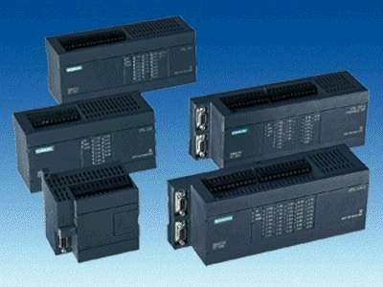

(Image 1: SIMATIC S7-200)

The SIMATIC S7-200 is the CPU for the lower level performance range.
It is available in various grades.

- The CPU is qualified for open and closed loop control tasks in machines and system construction.
- It is real time capable and offers extensive communication possibilities over a PROFIBUS
or PC/PPI cable and over a free programmable interface protocol.
- The SIMATIC S7-200 offers modular extensibility and integrated PID closed loop control functions.
- The program software STEP 7 Micro/Win enables a quick introduction in the programming and configuration.

3.1.2 SIMATIC S7-300
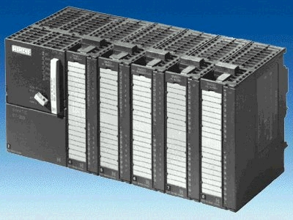
(Image 2: SIMATIC S7-300)

The SIMATIC S7-300 family offers the automation solutions for the lower and middle performance range.

Properties of the SIMATIC S7-300

- Program memory up to 85 K instructions
- Up to 1024 digital in- and outputs
- Multipoint capable interface for the configuration of smaller networks and for configuration with help of a PC/PG.
- Quick execution time in which the performance capable CPU executes 1024 binary instructions inside of 0.1 ms.
- Modular configuration and quick enhancements are possible through interface modules with an integrated back plane bus.
- Modular extensibility through an extensive program module of digital, analog, simulation and function modules to communications and other types of modules.
- Integrated functions: counters, positioning, closed loop control, and frequency measuring by the CPUs 312/314 IFM.
- Integrated PROFIBUS interface by the 300 2-DP Series. CPU also usable as a slave.
- Processing of extensive mathematical formulas.
- Preparation of cyclic HMI service integrated into the operating system of the CPU.
- Quick and simple configuration and programming with help from STEP 7.
- Extensive diagnostic possibilities with help from STEP 7. Error message buffer with time stamp and module diagnostic help the user during error searching.

3.1.3 SIMATIC S7-400
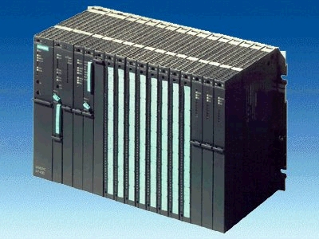
(Image 3: SIMATIC S7-400)

The CPUs of the family SIMATIC S7-400 build the solutions for the middle and higher performance range (e.g. automobile and machine tool construction or instrumentation and control).

Properties of the SIMATIC S7-400

- Program memory up to 660 K instructions.
- Up to 131056 digital in- and outputs.
- Multipoint capable interface for the configuration of smaller networks and for configuration with help of the PC/PG.
- Quick execution time that the performance capable CPU executes 1024 binary instructions inside of 0.1 μs.
- Modular configuration and quick enhancements are possible through interface modules with integrated back plane bus.
- An extensive program module of digital, analog, simulation and function modules to communications and other types of modules.
- Integrated PROFIBUS interface by the S7-400 2-DP Series. The profile
PROFIBUS-DP/FMS/PA and Industrial Ethernet are useable.
- Processing of extensive mathematical formulas.
- Preparation of cyclic HMI service integrated into the operating system of the CPU.
- Quick and simple configuration and programming with help from STEP 7.
- Extensive diagnostic possibilities with help from STEP 7. Error message buffer with time stamp and module diagnostic help the user during error searching.

3.2 Industrial communication
Communication from the process control to the field level is possible over the SIMATIC networks PROFIBUS, ETHERNET or TCP/IP. The family SIMATIC NET contains an array of products with different performance characteristics. They regulate over a operative system interface in which data exchange is possible over various levels, between various automation stations or various devices.
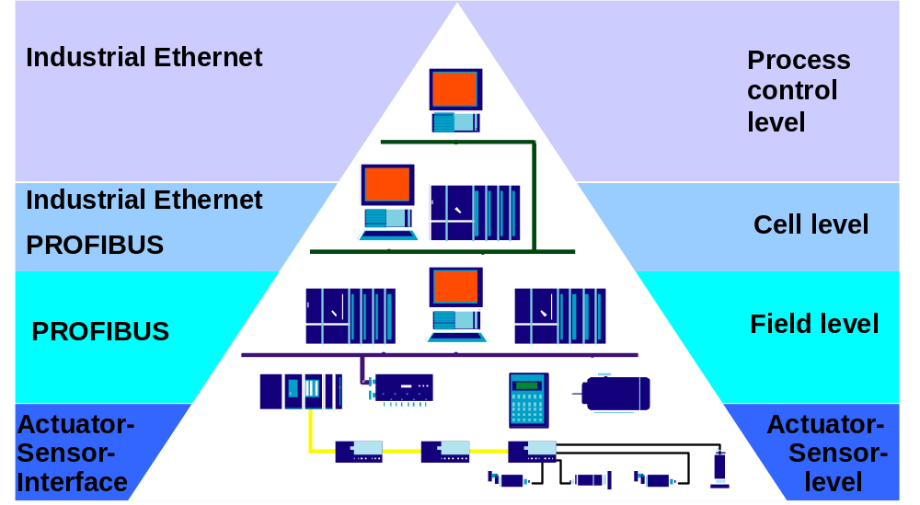

(Image 1: Network pyramid)

3.2.1 Industrial Ethernet
The Industrial Ethernet is used for the communication in the process control level. The transmission rate of 10 Mbit/s to 100 Mbit/s makes a quick data exchange between affiliated nodes by fast ethernet possible.
The transmission takes place over the coaxial cable, a twisted pair or fiber-optic cable. The ethernet contains the following advantages:

- A quick commission through a simple connection technology.
- A high availability where existing system operations are expandable in operation.
- Scalable performance through switching technology in which the adjustment of the transmission rate is possible.
- The linking of different application ranges like manufacturing and office.
- The company-wide connection over WAN (Wide Area Network) which is similar to ISDN or the internet.
- Investment security through the constant compatible future development.

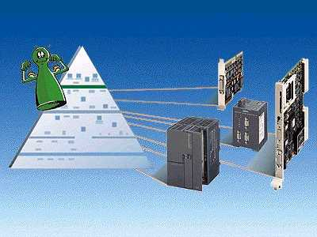
(Image 4: Components of Industrial Ethernet)

3.2.2 PROFIBUS
The PROFIBUS serves as a connection from field devices such as distributed I/O or drives with automation systems like SIMATIC S7. The PROFIBUS is a performance capable, assembly and open field bus system. It enacts over quick reaction times, an open interface and is applicable in different protocol variants.

The PROFIBUS-DP serves as a connection to distributed I/O with a transmission rate of up to 12 Mbit/s by an electrical or optical transmission.

The PROFIBUS-PA is the inherently safe type of the PROFIBUS, specified for data transmission in explosive fields (i.e. chemical industry).

PROFIBUS-FMS has strengths in the higher system level of the field level or also in the cell level and/or process control level with lower real time request.

An extensive product pallet for the protocol variants is available for the connection to the PROFIBUS.

The configuration and programming takes place over the software STEP 7, where extensive diagnostic possibilities are available to the user.

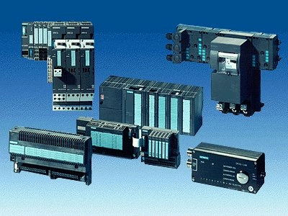
(Image 5: Components of the Industrial Ethernet)

3.2.3 AS-Interface
Valves, actuators and drives are found in the field level application. Completely different components must be controlled from automation technology. Today one appoints distributed I/O with the AS-Interface for this task.
The actors and sensors are connected through a two wire cable with a controller. Therefore data and energy are transported through a cable.

Advantages of the AS-Interface

- Panel free constructions
- Higher degree of protection, IP 65
- Wiring directly from a position
- Simpler and more flexible construction with 2 wire cables without applicable special knowledge
- PROFIBUS connection over DP/AS-Interface

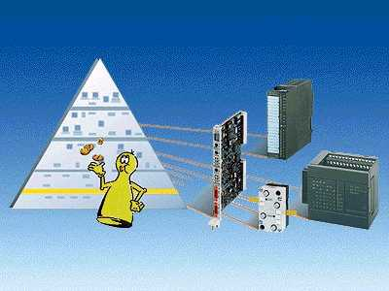
(Image 6: AS-Interface)

3.3 Human machine interface (HMI)
The components of the level SIMATIC HMI (Human Machine Interface) serve as an interface between machine and user. Functions, switches or process values are visualization on operator or touch panels. With the help of this visualization, error messages or measured values for the user can be easily represented. An optical detection of processes lightens operation to the user where he/she can quickly learn the external effects of his/her actions.
The Human Machine Interface is divided into 4 classes:

- Push Button Panels (PP 7 and PP 17), the innovative alternative for conventional operation field
- Text based displays OP 3, OP 7 and OP 17, for monitoring and operation in the machine range.
- Graphic based displays OP 25, OP 37, TP 27 and TP 37, for comfortable monitoring and
operation in the machine range
- Windows based systems like the OP 37 pro, the MP 370 or the MP 270 for operation in the
machine range.

The devices are configured with the configuration software Pro Tool that is available in three different performance variants suitable to device class.

The Human Machine Interfaces can be connected directly over MPI or PROFIBUS-DP to the automation systems. With configured function switches, command buttons or display elements one can receive direct access to the CPU.

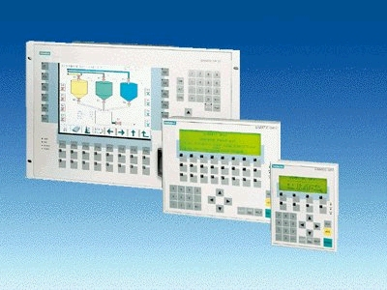
(Image 14: Human Machine Interfaces)

3.4 SIMATIC Industry Software

3.4.1 STEP 7
With the help of the program and configuration software STEP 7, automation systems SIMATIC S7-300 and S7-400 are programmed and configured. The hardware configuration takes place for CPUs with digital modules as well as for the connection of different components of a PROFIBUS, ETHERNET or other network components.

The programming software is IEC 61131 standard.

Functions of STEP 7

- Common data storage in a concise project structure
- Program creation in the languages STL, LAD and FBD. A change between the languages is possible.
- Adjustment of the CPU properties
- Adjustment of the module address
- Display of the module diagnostics, reading of the error message buffer
- Display of cross-reference and reference data

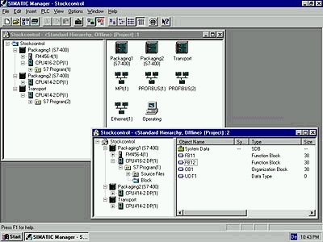
(Image 7: STEP 7)

3.4.2 Sequencer programming S7-GRAPH
The engineering software S7-GRAPH is a sequential control for the Norm IEC 61131-3. With it, the sequential and simultaneous procedures, i.e. by transfer lines described graphically, instead of being costly programmed. The process is analyzed in a sequence of steps and transitions (Transitions found between the steps) in an overview representation. Afterwards the contents of the step can be programmed. The transitions can also be programmed in the LAD or FBD language.
One quickly receives a programming concept overview with this software. Many various diagnostic functions are available to the user in this software.

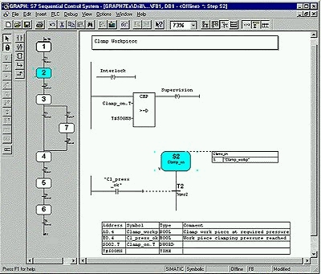
(Image 8: S7-GRAPH)

3.4.3 state control S7-HiGRAPH
S7-HiGraph allows the description of asynchronous processes with help from state graphs. With this software, the states from the processes and aggregates describe the possible state transitions (transitions) graphically. The free positional graphical elements cater for the important flexibility. Through the simple integrated monitoring and message functions, you can easily analyze errors and therefore reduce downtime. Automatic as well as manual operation can be described with state graphs. This graphical display is not only applicable for the PLC programmer, but also for the machine builder (Tech) and commission and service engineer.
S7-HiGraph is applicable for the automation systems SIMATIC S7-300 (recommended for CPU 315 and higher), SIMATIC S7-400, SIMATIC C7 (recommended for C7-626 and higher) and SIMATIC WinAC.

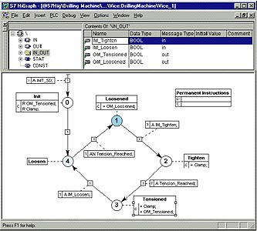

(Image 9: S7-HiGRAPH)

3.4.4 High level language S7- SCL
S7-SCL (Structured Control Language) is a PASCAL type higher level language optimized for the programming of the stored-program control.
S7-SCL achieved the PLC Open Base Level-Certificate.
S7-SCL allows:
- Simple and fast program creation
- Better quality of the PLC-Program
- Better articulation
- Simpler debugging
For this reason, the user is in the situation to formulate time efficient and cost effective solutions for automation tasks.
The software can be used for all automation systems SIMATIC S7-300 (for CPU 314 and higher), SIMATIC S7-400 and SIMATIC C7 as well as SIMATIC WinAC.

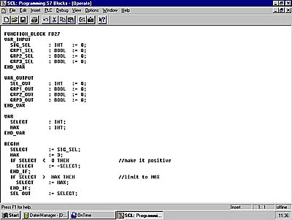

(Image 10: S7-SCL)

3.4.5 Soft- PLC SIMATIC WinAC basis
SIMATIC WinAC Basis is the software based PC based control solution. It is used when smaller control tasks should be resolved together with typical PC tasks, particularly for cost effectiveness.
The Soft- PLC WinAc Basis combines control and technological tasks with standard applications for visualization, data processing and communication. The software works from the base of operating system Windows NT.
If one demands hard and strict real-time requirements, SIMATIC WinAC RTX is available. It is attached directly to Windows NT and guarantees deterministic behavior for the control section with a real-time expansion.

Components of the SIMATIC WinAC

Controlling
The operation of the Slot-PLC is identical to the handling of a hardware PLC (e.g. CPU 315-2 DP).
The programming and the diagnostics take place over the standard tools of the SIMATIC Manager (LAD/FBD/STL Editor, Monitor/ModifyVariable).
You can simply affect the performance of the Soft-PLC over priority control (from Windows NT real-time response to secondary application in Windows NT).
The security of the PLC is guaranteed through password security with which all taken effects on the control are prevented.
Remanent data offers protection against system failure.

Visualization
Possibilities for the creation of a B&B operator interface are displayed over the SIMATIC WinAC data elements.
Simple B&B operator interfaces are displayed with the Soft-Container. Visual Basic also offers possibilities for realization of HMI-operator interfaces.
ProTool Pro ist the comfortable and quick configuration of HMI.

Computing
The data exchange of the PLC is accomplished with the PC. Data elements are dealt with here (SIMATIC Data Control). With the help of data elements, Windows-objects (OCX components) are simply connected with the areas of Soft-PLC (e.g. Memory bit words, inputs and outputs,...).

Networking
Over a data element, data also exchanges with the Soft-PLC over a normal office network (Ethernet) (only by the SIMATIC S7 416-2 DP ISA).

he Windows Logic Controller

The Windows Logic Controller (WinLC) represents the software solution of a CPU. You can display the functions of the CPU on a PC with WinLC. The program WinLC simulates the complete operation package of a CPU 315-2 DP and the WinLC software would also be customized to the CPU 315-2 DP. The arrangement of the error LEDs or the operation type switch corresponds to the layout of the hardware CPU. 1024 digital and 128 analog inputs can be processed from the WinLC. Therefore the peripheral connection takes place over a distributed I/O, e.g. ET 200M.

The control performance depends on the performance capability of the processor and RAM as well as
from the adjusted cycle time of the WinLC software. The cycle time of the WinLC can be set to be dependent on the control tasks. A cycle of WinLC consists of the reading of the inputs in the process image input table, program execution, the creation of the process image output table such as the execution of the waiting time until the created minimal cycle time is reached. In the remaining time, Windows NT finishes the rest of the active tasks.

A real-time solution forms the Slot-PLC. The Slot-PLC responds in a function package of CPU 416-2 DP which shows deterministic response with short reaction times and works independent from the operating system Windows NT and is applications. A restart of the operating system in operation of the Slot-PLC is possible.

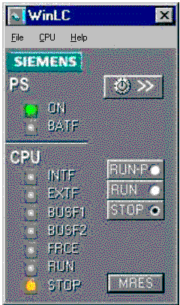

(Image 11: WinLC) (Image 12: Advantageous SIMATIC WinAC)

3.4.6 SIMATIC ProTool / Pro
HMIs are configured with ProTool and/or ProTool/Pro which serves as an interface between man and machine (HMI- Human Machine Interface).
Pro Tool enables a simple and quick conversion of ideas into a simple and clear images for the visualization system. The advantages can be used by the Windows environment, i.e. the connection from graphics which would be created with standard graphic programs. ProTool can be integrated in the SIMATIC MANAGER, where the taking over of the symbol tables is possible without problems. The configuration software can naturally also be used as a standalone version.

Operator panels from type OP 3, OP 7 and OP 17 are configured with the cost effective software ProTool/Lite. The graphical operator panels OP 27, OP 37, TP 27, and TP 37 require the software ProTool. Windows-based systems like a OP 37 Pro are configured with ProTool/Pro.

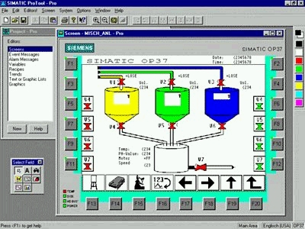

(Image 13: ProTool/Pro)

3.4.7 HMI SIMATIC WinCC
SIMATIC WinCC stands for „Windows Control Center“. WinCC is a performance capable process visualization system based on Windows NT or Windows 95. The 32-Bit system offers preemptive multi tasking so that you can quickly and effectively react to process events and alarms. WinCC lets you integrate into an existing automation system problem free. It enacts over a common database with standard applications for data exchange with other windows applications or with further SIMATIC components. Object libraries for simple configuration of graphic elements are also integrated in WinCC.

Properties

- Graphic editor for comfortable creation of the process images
- Message system with archive system
- Measured value archiving
- The report system
- Options for the configuration of basic functionality
- Common database

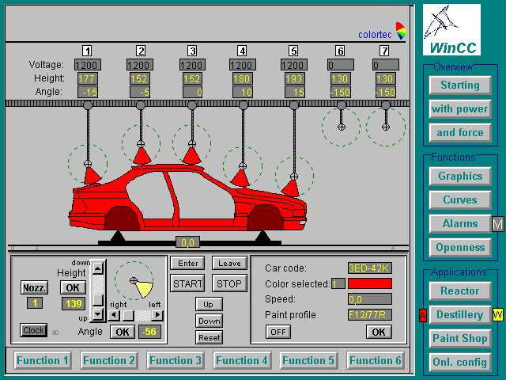

(Image 14: WinCC)

3.4.8 Process control system PCS 7
PCS 7 is the process control system in the automation concept TIA. It is based on chosen and convenient components for operation as a control system. In addition come functional expansions, which ensure specific system performance from engineering over the Human Machine Interface by the peripheral control and also the demanding function package from the process instrumentation and control system.

Properties

- Defined start and restart
- Operation concept
- Control system message concept
- Access authorization
- Sign-of-life monitoring
- Real time synchronization
- Safe process control
- Libraries with prepared blocks
- Comfortable configuration
- Additional software pack for discontinued processes
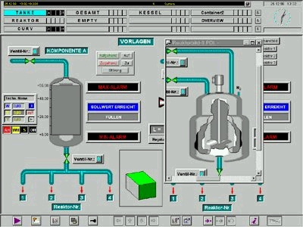

(Image 15: PCS7)

3.5. drive technology
Variable speed drives, regardless if a standard drive or a large drive, if a AC drive or
a DC drive are suitable in the frame of Totally Integrated Automation and also the SIMATIC world. From this comes the following advantages:

- Uniformity and passage from the control level to the drives
- The DRIVE engineering system is fully integrated into the STEP 7 environment
- SIMATIC Manager for common data administration
- The time cost by the integration of DRIVE technology in the automation solution is significantly reduced.

Here you find the following drive systems and drive components for different applications in the frame of TIA:

Low voltage motors
They are the first high performance AC motor set for the whole machine and system configuration- the solution for the future: maintenance free, dynamic and high performing.

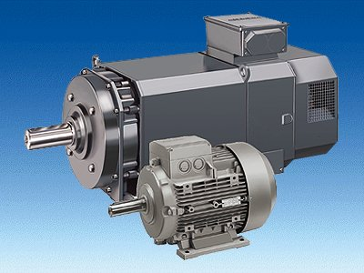
(Image 16: Low voltage motors)

Frequency converter SIMOVERT MASTERDRIVES
They make AC motors perform well at variable speeds. This device set is conceptual for world-wide operation. It is qualified for all connection voltages from 230 to 690 V and is qualified for world-wide use.

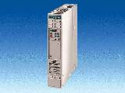
(Image 17: Frequency converter)

Standard converter
MICROMASTER and MICRO-/MIDIMASTER Vectors are frequency converters in the performance range of 120 W to 75 kW. They are usable on the smallest space through their compact construction type. The encoder free vector control also enables operation in the medium performance range for demanding applications.
COMBIMASTERs are compact units that exist of DS low voltage motors and frequency converters.
MICROMASTER Integrated are frequency converters (IP 65) that are applied directly to the DS low voltage motors of different manufacturers.
MICRO-/MIDIMASTER Ecos are specified for the requirements of heat, ventilation and air-conditioning industry conceptual frequency converters.

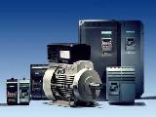
(Image 18: Standard converter)

Drive converters SIMOREG
SIMOREG drive converters are fully digital compact devices for three phase connections and serve for armature and field supply from variable speed DC current drive converters.
The range of rated current of the devices stretches from 15 to 2000 A and can be increased through parallel connection from SIMOREG devices.
Hoisting equipment, ski lifts, lifts, cranes, shear and other reversing drives count as well known applications of this device.

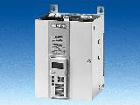
(Image 19: SIMOREG)

3.6. Operation and installation technology
3.4.1 Installation technology

Here you can find all that you require for the solution to different installation intentions:
Low voltages fuses
Residual current protection devices
Series chassis units
Insulation and monitoring devices
STAB-wall terminal block
SIKUS-stand terminal block
SIPRO meter cabinets
SIKUS 3200 series connection cabinet system
Installation terminal block
Busbar trunking system PL
Operation, switch-, message- and control systems
Building system technology with instabus EIB.

Via the AS-Interface, you are not only allowed to connect the simplest switch elements. SIMATIC NET also offers the connection between PROFIBUS and instabus EIB. Through this connection, a bridge between manufacturing and building system automation is built. It produces enormous advantages in uniformity, where the links for the AS-Interface and instabus EIB are not only integrated into the uniform configuration.
Through Totally Integrated Automation a common database is made with the advantage of making a required simulation and process dependent control from lighting, heat, air-conditioning and ventilation as simple as possible.

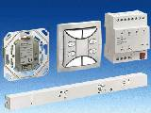
(Image 20: instabus EIB)

